Question 1
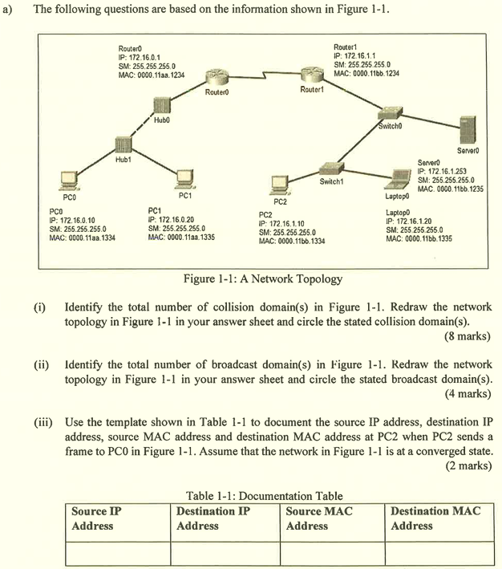
(i)
7 collision domains
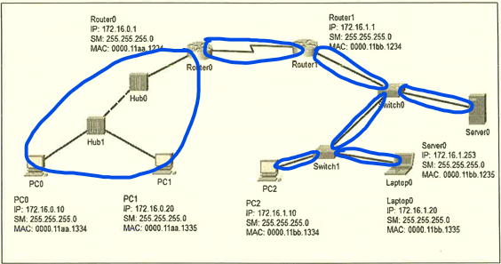

(ii)
3 broadcast domains
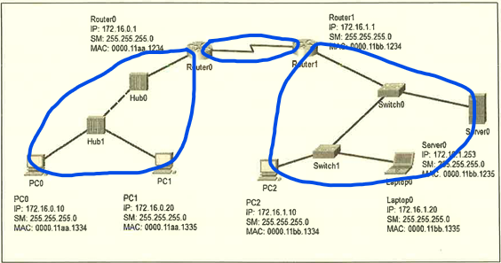

(iii)

Source IP Address | Destination IP Address | Source MAC Address | Destination MAC Address
172.16.1.10 | 172.16.0.10 | 0000.11bb.1334 | 0000.11bb.1234

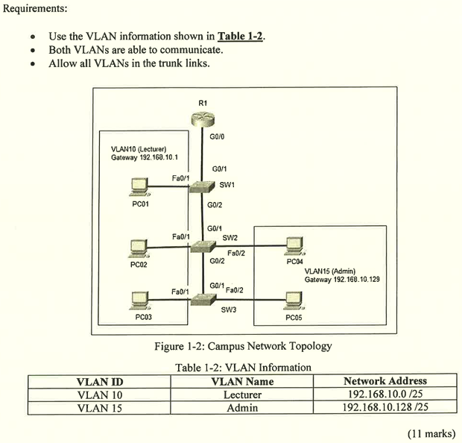
SW2
enable
config terminal
vlan 10
name Lecturer
vlan 15
name Admin
interface Fa0/1
switchport mode access
switchport access vlan 10
no shutdown
iterface Fa0/2
switchport mode access
switchport access vlan 15
no shutdown
interface range G0/1-2
switchport mode trunk
switchport trunk allowed vlan 10,15
no shutdown

R1
enable
config terminal
interface G0/0.10
encapsulation dot1q 10
ip address 192.168.10.1 255.255.255.128
interface G0/0.15
encapsulation 192.168.10.129 255.255.255.128
interface G0/0
no shutdown

Question 2
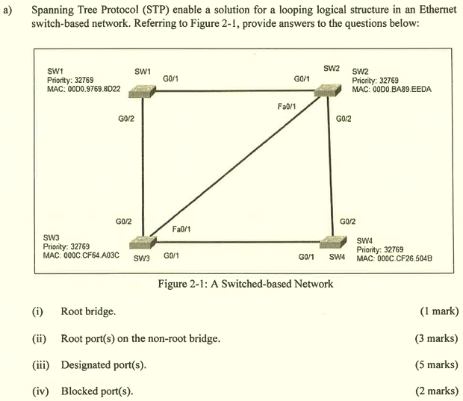
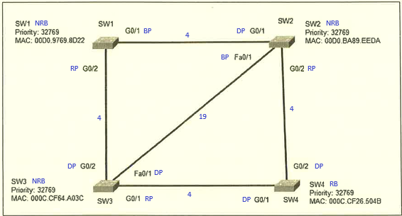

(i) SW4

(ii)
- SW1: G0/2
- SW2: G0/2
- SW3: G0/1

(iii)
- SW2: G0/1
- SW3: G0/2, Fa0/1
- SW4: G0/1, G0/2

(iv)
- SW1: G0/1
- SW2: Fa0/1

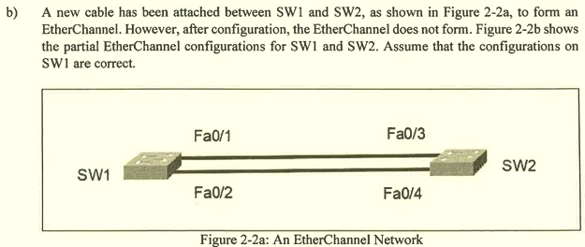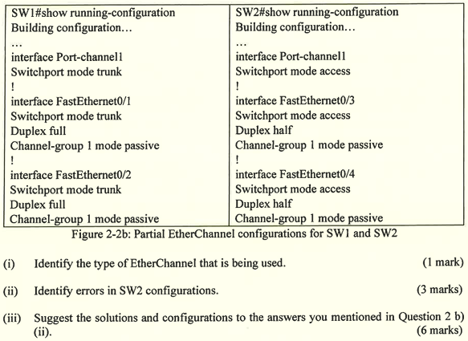
(i) LACP

(ii)
- The switchport mode of interface Port-channel 1 is configured wrongly, it should be trunk mode instead of access mode.
- The switchport mode of interface FastEthernet0/3 and FastEthernet0/4 are configured wrongly, it should be trunk mode instead of access mode.
- The duplex mode of interface FastEthernet0/3 and FastEthernet0/4 are configured wrongly, it should be full duplex instead of half duplex.
- The EtherChannel mode of interface FastEthernet0/3 and FastEthernet0/4 are configured wrongly, it should be in active mode instead of passive mode.

(iii)
- The switchport mode of interface Port-channel 1 should be set to trunk mode.
interface Port-channel1
switchport mode trunk
- The switchport mode of interface FastEthernet0/3 and FastEthernet0/4 should be set to trunk mode.
interface range Fa0/3-4
switchport mode trunk
- The duplex mode of interface FastEthernet0/3 and FastEthernet0/4 should be set to full duplex.
interface range Fa0/3-4
duplex full
- The EtherChannel mode of interface FastEthernet0/3 and FastEthernet0/4 should be set to active mode.
interface range Fa0/3-4
channel-group 1 mode active

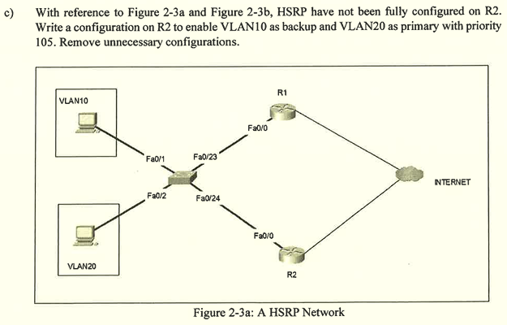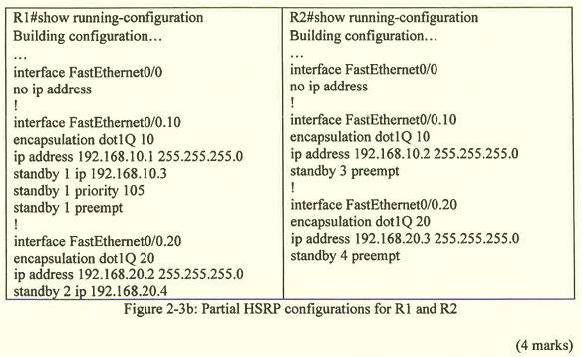

enable
configure terminal

interface FastEthernet0/0.10
no standby 3 preempt
standby 1 ip 192.168.10.3

interface FastEthernet0/0.20
no standby 4 preempt
standby 2 ip 192.168.20.4
standby 2 priority 105
standby 2 preempt

Question 3
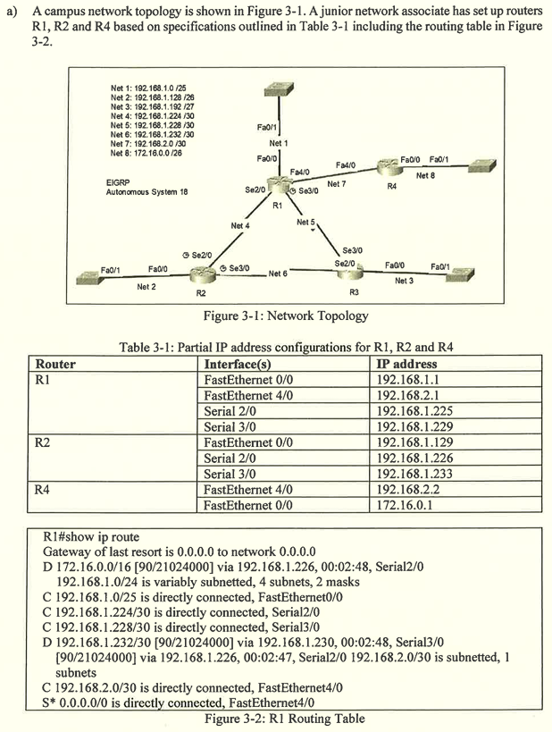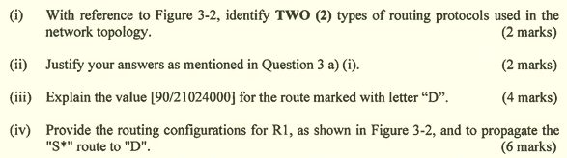
(i)
- D is Enhanced Interior Gateway Routing Protocol (EIGRP)
- S* is Default Static Route

(ii)
- The routes with destination subnet address 172.16.0.0/16 and 192.168.1.232/30 are labelled with 'D'. It means that these two routes are learned via EIGRP.
- The routes with destination subnet address 0.0.0.0/0 is labelled with 'S*'. It means that this route is being set as the static default route.

*Different routing protocol(RIP, OSPF,EIGRP like chicken to duck)will use AD instead of metrics (lowest ad better)
(iii)
- The value "90" indicates the administrative distance which represents the trustworthiness of the route. The lower the administrative distance, the higher the trustworthiness.
- The value "21024000" indicates the metric. Since the route is learned via EIGRP, the metric is shown based on the bandwidth, delay, reliability and load.

(iv)
en
conf t
interface f4/0
no switchport
ip route 0.0.0.0 0.0.0.0 f4/0
router eigrp 18
network 192.168.1.0 0.0.0.127
network 192.168.1.224 0.0.0.3
network 192.168.1.228 0.0.0.3
redistribute static

- This situation is the Evil Twin AP attack which is one of the man-in-the-middle attack.
- The attacker creates a rogue AP and configures its SSID the same as the legitimate AP in the restaurant.
- This can confuse the customers and let them accidentally connect to the attacker's rogue AP. Thus, the attackers can capture the data packets and network resources on their wireless devices.

- Personal
  - This authentication method is suitable for home or small office networks.
  - It authenticates users using a pre-shared key.
  - The wireless client authenticates with the wireless router using the pre-shared key.
  - No special authentication server is required.
- Enterprise
  - This authentication method is suitable for enterprise networks.
  - It requires a remote authentication dial-in user service (RADIUS) authentication server.
  - Devices must be authenticated by RADIUS authentication server and users should authenticate via 802.1X standard, which uses Extensible Authentication Protocol (EAP) for authentication.

Question 4
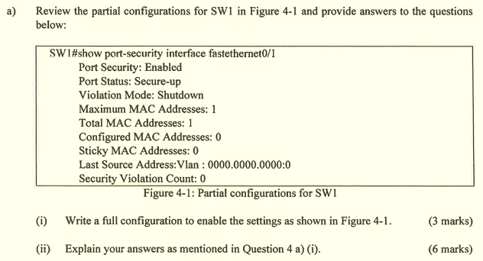
(i)
enable
configure terminal
interface fastethernet0/1
switchport port-security
switchport port-security violation shutdown
switchport port-security maximum 1

(ii)
- interface fastethernet0/1
  - Enter the configuration of the interface fastethernet0/1
- switchport port-security
  - enable port-security feature
- switchport port-security violation shutdown
  - set the port-security violation mode to shutdown. It will put the interface into error-disabled state while the maximum mac-address allowed has exceeded. It will also increase the violation counter by 1 and generate syslog messages. It will also drop the packet with an unknown MAC address. In order to re-enable the interface, the network administrator needs to manually enable it using command shutdown and no shutdown.
- switchport port-security maximum 1
  - set the maximum allowed mac-address for this interface into 1
- switchport port-security mac-address sticky
  - configure the way of learning the mac address into sticky mode, it will dynamically learn the MAC address and "stick" it into the running configuration. Thus, the MAC address still remains after restarting the switch.

- Shutdown
  - This violation mode will change the state of the interface into error-disabled state when the maximum MAC address allowed has exceeded.
  - It will increase the violation counter by 1 when violation occurs.
  - It will also generate syslog messages.
  - It will drop the packet with an unknown MAC address.
  - In order to re-enable the interface, the network administrator needs to manually enable it using command shutdown and no shutdown.
- Restrict
  - This violation mode will drop the packet with unknown MAC address until the network administrator removes a sufficient number of secure MAC addresses or increases the maximum MAC address number when a violation occurs.
  - It will not disable the interface when violation occurs.
  - It will increase the violation counter by 1.
  - It will generate a syslog message.
- Protect
  - This violation mode is less secure compared to shutdown and restrict.
  - It will drop a packet with an unknown MAC address until the network administrator removes a sufficient number of secure MAC addresses or increases the maximum MAC address number when a violation occurs.
  - It will not disable the interface when violation occurs.
  - It will increase the violation counter by 1.
  - It will not generate a syslog message.

- Local AAA Authentication
  - It stores usernames and passwords locally on the network device.
  - It authenticates users against the local database.
  - It is ideal for a small network.
- Server-Based AAA Authentication
  - Router accesses the central AAA server.
  - It stores usernames and passwords for all users.
  - The router uses Remote Authentication Dial-In User Service (RADIUS) or Terminal Access Control Access Controller System (TACACS+) to communicate with the AAA server.
  - It is ideal when there are multiple switches and routers.

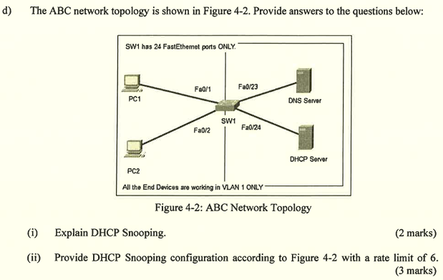
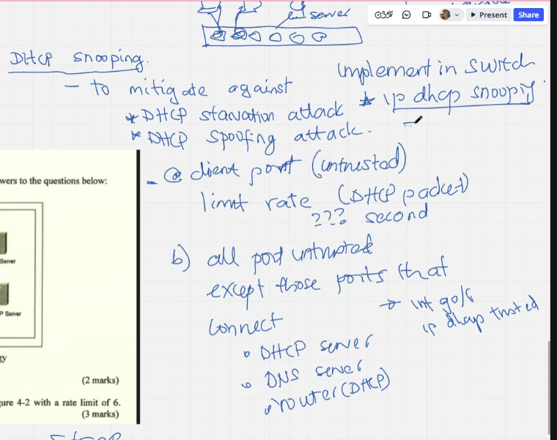
(i)
- DHCP Snooping is used to filter DHCP messages and set limit rate for DHCP traffic on untrusted ports. Prevents DHCP starvation and DHCP spoofing attacks.
- The devices under administrative control will be considered as trusted devices and the port attached to them will be explicitly configured as trusted ports.
- The devices outside the network will be treated as untrusted devices and the access ports attached to them will be considered as untrusted ports.
- The untrusted port should be configured with a rate limit.

(ii)

ip dhcp snooping
ip dhcp snooping vlan 1

int range Fa0/1-2
sw m a
ip dhcp snooping limit rate 6

int range Fa0/23-24
sw m a
ip dhcp snooping trust

